

A Peek at Our Week

Week of August 1-5, 2016



**Ah-“Mason” Happenings in the Fifth Grade**

Week of December 4-8



Follow our school on Twitter @HillCityHawks.

Dear Parents,

Our Pancake Christmas Breakfast will be on December 21st. We will be having pancakes and will begin serving at 8:30. If you are interested in volunteering to help set up, cook, and clean up, please let your child’s homeroom teacher know. You will find a list of supplies in your child’s Friday folder. Please circle what you plan to send and return it to school with your child.

We will be having Tacky Hat/Sweater Dollar Day on Friday, December 8th. Please remember it is a $1.00 for the hat and a $1.00 for the sweater, so if your child wishes to do both, it will be $2.00. Remember all of the proceeds from our Dollar Days go directly towards future events for your 5th grader. We will also be making our ornaments on this day. Lastly, Hill City is sponsoring a local nursing home for Christmas. If you are interested in sending a little joy to the elderly, see the information in your child’s folder.

Fifth Grade Teachers

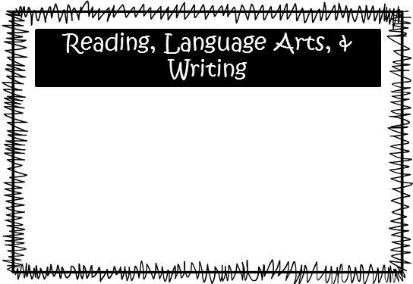

Students completed a writing benchmark in later October, and we have just gotten the benchmarks back. Students will be working on self-assessing their writing, developing a plan for improvement, and will begin writing their revised version. We will continue to emphasize reading fluency and comprehension with a focus on informational texts. Students will also continue working on text structure and sentence composition.

Please consider donating Vienna sausages for Snack Packs!

Upcoming Events:

* December 8th—Tacky Hat/Sweater Dollar Day
* December 21st—Christmas Breakfast
* December 22nd-January 5th—Christmas Break

Email Addresses:

[Amandalo@pickenscountyschools.org](mailto:Amandalo@pickenscountyschools.org)

[Ashleypatterson@pickenscountyschools.org](mailto:Ashleypatterson@pickenscountyschools.org)

Brandimcentire@pickenscountyschools.org

[Carolsmith@pickenscountyschools.org](mailto:Carolsmith@pickenscountyschools.org)

Jenniferwilds@pickenscountyschools.org

Things to Know



Science: McEntire’s students will continue with studies of landforms. Los’ students will begin studying animal classification.

Social Studies: We will continue our studies of the Dust Bowl and Great Depression. We will test over this material on December 19th.

**Smith:** We are working with dividing decimals—whole numbers divided with decimals, decimals divided by whole numbers, and decimals divided by decimals.

**McEntire:** After the break, we will be beginning to divide whole numbers with decimals.

Math